(**S**erial **ATA**) The standard hardware interface for connecting hard drives, solid state drives (SSDs) and CD/DVD drives to the computer. Introduced in 2001, all computers for consumer use employ the SATA interface. However, for mission critical applications, servers and high-end workstations may use the SCSI serial interface instead (see [Serial Attached SCSI](http://www.pcmag.com/encyclopedia/term/56118/serial-attached-scsi)).   
  
**eSATA and Powered eSATA**  
SATA drives are internal and cabled directly to the motherboard, while "eSATA" ports on the back of the computer accept external SATA drives. The "powered" version means the drive power comes from the port rather than the wall outlet.  
  
**SATA, PATA and IDE**  
SATA is the faster serial version of the parallel ATA (PATA) interface. Both SATA and PATA are "integrated drive electronics" (IDE) devices, which means the controller is in the drive, and only a simple circuit is required on the motherboard. Although SATA is an IDE technology, "IDE" refers to PATA (for details, see [IDE](http://www.pcmag.com/encyclopedia/term/44707/ide), [AHCI](http://www.pcmag.com/encyclopedia/term/62251/ahci) and [PATA/SATA specifications](http://www.pcmag.com/encyclopedia/term/67870/pata-sata-specifications)). See [mSATA](http://www.pcmag.com/encyclopedia/term/64801/msata) and [SATA Express](http://www.pcmag.com/encyclopedia/term/66872/sata-express).

 **SATA           Data Transfer Rate**  
 **Version      Gbits/sec  MBytes/sec  Year**  
  
 1.0  I          1.5        150      2001  
 2.0  II, 3G     3.0        300      2004  
 3.0  III, 6G    6.0        600      2009  
 3.2  Express   16.0       1969      2013

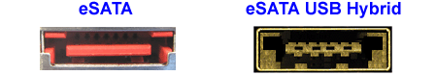

**eSATA Ports**

These ports connect external SATA drives. The hybrid port supports both powered eSATA (eSATAp) and USB devices, and drives can be plugged in and out with the computer on (hot swappable). For more details, see [eSATA USB Hybrid Port](http://www.pcmag.com/encyclopedia/term/64729/esata-usb-hybrid-port).

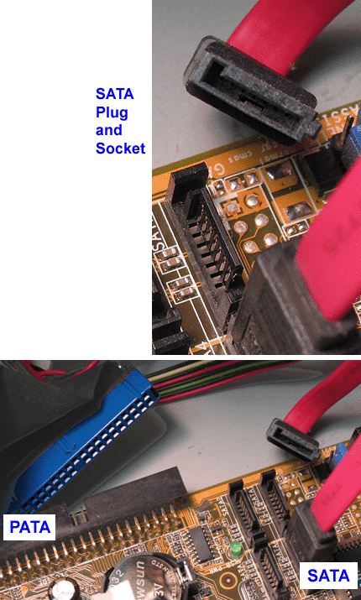

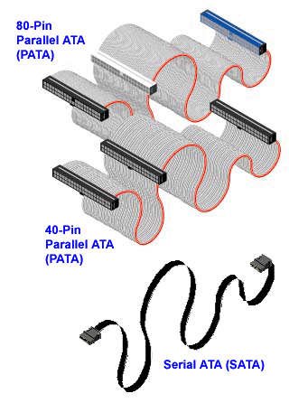

**SATA and PATA Cables**

SATA cables easily fit inside a case, whereas the old PATA ribbons were cumbersome. As is visible on this earlier motherboard that used SATA hard drives and PATA CD/DVD drives, four SATA sockets took less room than one PATA.